UI Health Care Training Theater

The UI Health Care Training Theater is a 7,000 square foot facility located in the lower level of the Iowa City Public Library.
The Training Theater has its own entrance on the west end of the library building, which is accessed from the Pedestrian Mall and is located next to The Wedge and Capanna Coffee and Gelato Shop. The entrance is clearly marked with the UI Health Care logo.
The Training Theater is located in the center of the downtown Iowa City pedestrian mall. The Training Theater cannot be accessed from the public library.

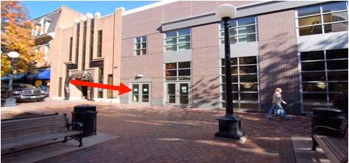
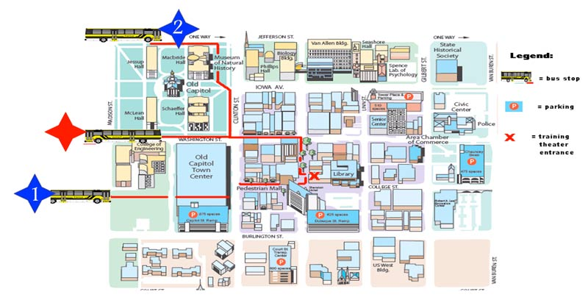

Transportation Options
Cambus – weekday academic period (verified 9/1/08)
Departing North Hospital: Pentacrest Route
Pentacrest leaves from the VA Loop starting at 0631. Bus comes every 15 minutes (0646, 0701, 0716, 0731, 0746 etc.).
A. Exit at Old Capitol Town Center. Proceed toward Iowa City Public Library.
Departing South Hospital: Blue Route
Take the Blue Route from UI Hospitals and Clinics Ramp 2. The Blue Route comes every 15 minutes starting at 0626 to 0741 (0641, 0656, 0711, 0726, and 0741). The Blue Route changes to every 10 minutes starting at 0756 and runs on the 6’s (0806, 0816, 0826 etc.).
Blue Route Exit Options
1. Exit at U of Iowa Main Library.
Go up steps to Old Capitol Town Center.
Proceed through the Town Center to reach the Pedestrian Mall.
Proceed toward Iowa City Public Library.
2. Exit at McBride Hall
Head toward Iowa Book and Supply.
Go down Washington Street.
Turn right at Pedestrian Mall.
Proceed toward Iowa City Public Library.
Returning to UI Hospitals and Clinics: Red Route
A. Take the Red Route from the north side of the Old Capitol Town Center.
Bus comes every 10 minutes on the 3’s (i.e. 1103, 1113, 1123).
Exit at UI Hospitals and Clinics Ramp 2.
For additional information, printable maps and schedules visit the cambus website.
City Bus
Check the Iowa City Transit pages for information on city bus routes from the hospital to downtown.
Car
Ramp Parking
See map to locate the five city parking ramps. Two ramps are staffed with cashiers to pay when exiting; three ramps offer pre-payment options.
Metered Parking
Not recommended. Time allotments are less than most training sessions.
On Street Parking
The neighborhoods east of downtown Iowa City offer very limited on-street free parking. Allow ample time to locate a space and walk to the Training Theater.

