The Informed Consent Document (ICD) or Consent Letter (CL) template includes all of the elements of consent required by the Federal Regulations to ensure appropriate consent for research subjects.

This checklist is intended for use with studies that meet the regulatory criteria of an expedited category of review (§45 CFR 46.110) and not intended for research that qualifies under an Exemption category (§45 CFR 46.104).

The purpose of this checklist is to:
- Facilitate consistency between the ICD or CL and the eResearch (HawkIRB) application for social, behavioral and educational (SBER) research
- Assist researchers when submitting new applications and modifications to existing applications
- Assist HSO reviewers, compliance staff, IRB Chairs and IRB members when reviewing new studies, modifications, and studies selected for monitoring
The following tables include the consent headings and references to applicable sections of the HawkIRB application:
- Informed Consent Document/Consent Letter/Waiver of Documentation (no subject signature required on consent materials)
  - Includes template sections that are in the majority of ICDs

- Informed Consent Document/Consent Letter/Waiver of Documentation – Study Specific
  - Includes template sections that are unique to certain types of studies
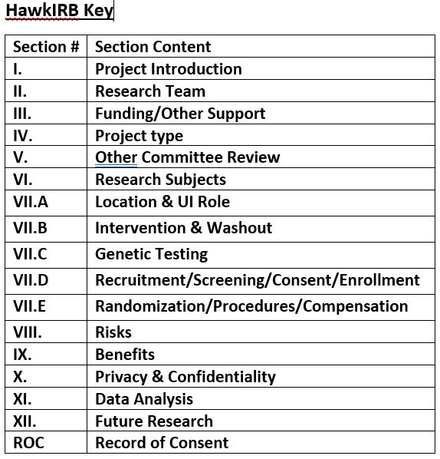

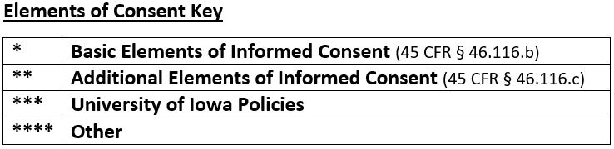

Consent Heading | N/A | Applicable IRB Section(s)
PI Name & Research Contact Information * |  | ☐ II.1 ☐ II.5
Title & Purpose of Study * |  | ☐ I.2 ☐ I.4
How Many People Will Participate** |  | ☐ VI.1 ☐ VI.6
How Long Will I Be in the Study * |  | ☐ VII.E.6
What Will Happen During This Study * |  | ☐ I.4  ☐ VII.A.1 - Location – May need to attach a Letter of Agreement  ☐ VII.D. 37 - 45 - Deception information  ☐ VII.E.1-2 - Randomization  ☐ VII.E. 3-4 - questionnaire, survey, interview guide – add to attachments  ☐ VII.E.6 - list of procedures - after consent to follow up/member checking
SSN Usage *** | ☐ N/A | ☐ VII.E.19 ☐ X.2
Data sharing* | ☐ N/A | ☐ ☐ X.4 ☐ X.6 ☐ XII.4
Audio/Video Recording/Photographs*** | ☐ N/A | ☐ VII.D.29 ☐ VII.E.5 ☐ X.4
What are the Risks of this Study* |  | ☐ VIII.1 ☐ VIII.2
What are the Benefits of this Study* |  | ☐ IX.1 ☐ IX.2
Will it Cost Me Anything to be in this Study** |  | No corresponding IRB section
Will I be Paid for Participating* | ☐ N/A | ☐ VII.E.9 – 19 - Compensation plan, attach Cash Handling Plan, if needed
Do the Researchers Have Financial Interest in Study*** | ☐ N/A | ☐ III.3
Who is Funding this Study*** | ☐ N/A | ☐ III.1
What if I am Injured as a Result of this Study* |  | No corresponding HawkIRB section
Will You Keep My Name on File to Give to Others * | ☐ N/A | ☐ X.6 ☐ XII.1 – 3 (as applicable)
What about Confidentiality * |  | ☐ X.4 – 6 (as applicable)
Is Being in this Study Voluntary* |  | ☐ VII.D.29
- What if I Decide to Drop Out of Study* |  | ☐ VII.E.6
- Will I Receive New Info about Study while Participating** |  | ☐ Protocol
- Can Someone Else End my Participation in this Study** |  | ☐ III.1 (sponsor) ☐ VI.13 ☐ VIII.1  ☐ Protocol (sponsor may stop participation)
What if I Have Questions * |  | ☐ II.5
Optional Agreements *** | ☐ N/A | ☐ VII.E.5 ☐ VII.E.6 ☐ XII.4
Study SpecificN/A
Consent Heading | N/A | Applicable HawkIRB Section
Registry/Repository * | ☐ N/A | ☐ XII.2 ☐ XII.4
Certificate of Confidentiality **** | ☐ N/A | ☐ X.7 ☐ III.1 (NIH funded) ☐ VIII.1 ☐ VIII.2
Studies Focusing on Violence, Abuse, Self- Injury ** | ☐ N/A | ☐ I.4 ☐ I.5 ☐ VII.E.4 ☐ VII.E.6 ☐ VIII.1 ☐ VIII.2
Signature Boxes  Minor & parent ****  Legally Authorized Representative *  Person Who Obtained Consent signature****  ●if by mail or email | ☐ N/A  ☐ N/A  ☐ N/A | ☐ VI.6 ☐ VII.D.29  ☐ VI.28 ☐ VI.32 ☐ VII.D29  ☐ VII.D.29 ☐ VII.D.30
Translated ICD – Non-English version**** | ☐ N/A | ☐ VI.16 ☐ VII.D.29 ☐ VII.D.30

