The Informed Consent Document (ICD) template includes all of the elements of consent required by the Federal Regulations to ensure appropriate consent for research subjects.

The purpose of this checklist is to:
- Facilitate consistency between the Informed Consent Document and the eResearch (HawkIRB) application
- Assist researchers when submitting new applications and modifications to existing applications
- Assist HSO reviewers, compliance staff, IRB Chairs and IRB members when reviewing new studies, modifications, and studies chosen for monitoring
The following tables include the consent headings and references to applicable sections of the HawkIRB application:
- Informed Consent Document – General
  - Includes template sections that are in the majority of ICDs

- Informed Consent Document – Study Specific
  - Includes template sections that are unique to certain types of studies
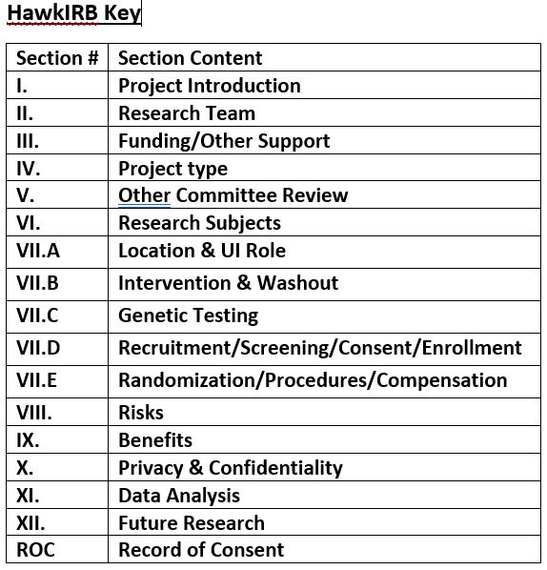

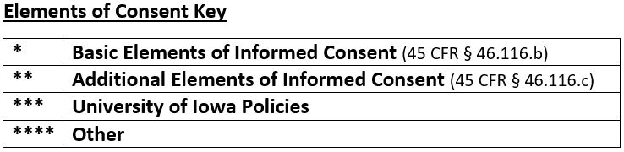

Informed Consent Document – General
Consent Heading | Element N/A | Applicable HawkIRB Section
PI Name & Research Contact Information * |  | ☐ II.1 ☐ II.5
Title & Purpose of Study * |  | ☐ I.2 ☐ I.4
How Many People Will Participate** |  | ☐ VI.1 ☐ VI.6
How Long Will I Be in the Study * |  | ☐ VII.E.6
What Will Happen During This Study * |  | ☐ I.4 ☐ VII.E.6-8  Check ICD for all that are applicable  ☐ V.1-8 – drug ☐ V.3 – contrast ☐ V.9-19 – radiation  ☐ V.20 – recombinant DNA\RNA  ☐ V.23 – VA Consent (only for IRB-03) ☐ VII.B.2 ☐ VIII.C.1  ☐ VII.D.26 ☐ VII.D.37-45 ☐ VII.E.2
SSN Usage *** | ☐ N/A | ☐ VII.E.19 ☐ X.2
Data/specimen sharing* | ☐ N/A | ☐ VII.B.1 (Registry, Repository, possibly Clinical Trial)  ☐ VII.C.7 ☐ X.4 ☐ X.6 ☐ XII.4
Audio/Video Recording/Photographs*** | ☐ N/A | ☐ VII.E.5 ☐ VII.E.6
What are the Risks of this Study* |  | ☐ VIII.1 ☐ VIII.2
What are the Benefits of this Study* |  | ☐ IX.1 ☐ IX.2
What Other Treatments are There** | ☐ N/A | ☐ IV.1 (Regular Review in compliance with ICH-GCP)  ☐ VII.B.1 (clinical trial)  (required if both responses are selected)
Will it Cost Me Anything to be in this Study** |  | No corresponding HawkIRB section
Will I be Paid for Participating* | ☐ N/A | ☐ VII.E.9-19
Do the Researchers Have Financial Interest in Study*** | ☐ N/A | ☐ III.3
Who is Funding this Study*** | ☐ N/A | ☐ III.1
What if I am Injured as a Result of this Study* |  | No corresponding HawkIRB section
Will You Keep My Name on File to Give to Others * | ☐ N/A | ☐ X.6 ☐ XII
What about Confidentiality * |  | ☐ VII.C.6 ☐ X
Will My Health Information be Used During this Study**** | ☐ N/A | ☐ V.21 ☐ V.25 ☐ VII.A.1 ☐VII.E.6 ☐ ROC.1
Report unexpected findings from research testing **  (conducted with clinical quality procedures) | ☐ N/A | ☐ VII.E.6 ☐ VIII.1
Is Being in this Study Voluntary* |  | ☐ VII.D.29
- What if I Decide to Drop Out of Study* |  | ☐ VII.E.6
- Will I Receive New Info about Study while Participating** |  | ☐ Protocol
- Can Someone Else End my Participation in this Study** |  | ☐ III.1 (sponsor) ☐ VI.13 ☐ VIII.1 (i.e. if you become  pregnancy is exclusion criteria or study intervention poses a risk  to a fetus)  ☐ Protocol (sponsor may stop participation)
What if I Have Questions * |  | ☐ II.5 ☐ ROC.4
Optional Agreements *** | ☐ N/A | ☐ VII.B.1 (Registry, Repository, possibly Clinical Trial)  ☐ VII.C.9 ☐ VII.E.5 ☐ VII.E.6 ☐ XII.4

Informed Consent Document – Study Specific
Consent Heading | Element N/A | Applicable HawkIRB Section
Registry/Repository * | ☐ N/A | ☐ VII.B.1 ☐ XII.2 ☐ XII.4
Genetic Research ** | ☐ N/A | ☐ VII.C.1
GINA ** | ☐ N/A | ☐ VII.C.1
ROC *** | ☐ N/A | ☐ V.21 ☐ V.25.a ☐VII.A.1 ☐ ROC.1 (does meet)
Randomization process/Randomized Clinical Trial * | ☐ N/A | ☐ VII.E.2 ☐ VII.E.6
Pregnancy Testing for minors *** | ☐ N/A | ☐ VI.6 ☐ VI.13 ☐ VII.D.26 ☐ VII.E.6
MRIs and Imaging Scans *** | ☐ N/A | ☐ V.9-16 ☐ VII.E.6 ☐ VIII.1 ☐ VIII.2
GWAS ** | ☐ N/A | ☐ VII.C.8 ☐ X.6
Placebo * | ☐ N/A | ☐ V.1.a ☐ VII.B.6
Women capable of becoming pregnant during study ** | ☐ N/A | ☐ V.9-16 ☐ VIII.1 ☐ VIII.2
Testing for Reportable Diseases *** | ☐ N/A | ☐ VI.13 ☐ Protocol
Radiation *** | ☐ N/A | ☐ V.9-16 ☐ VII.E.6 ☐ VIII.1 ☐ VIII.2
Certificate of Confidentiality **** | ☐ N/A | ☐ X.7 ☐ III.1 (NIH funded) ☐ VII.1 ☐ VII.2
Studies Focusing on Violence, Abuse, Self- Injury ** | ☐ N/A | ☐ I.4 ☐ I.5 ☐ VII.E.4 ☐ VII.E.6 ☐ VIII.1 ☐ VIII.2
Signature Boxes  Minor & parent ****  Legally Authorized Representative *  Person Who Obtained Consent signature****  ●if by mail or email | ☐ N/A  ☐ N/A  ☐ N/A | ☐ VI.6 ☐ VII.D.30  ☐ VI.28 ☐ VI.32 ☐ VII.D.29  ☐ VII.D.29 ☐ VII.D.30
Translated ICD – Non English version**** | ☐ N/A | ☐ VI.16 ☐ VII.D.29 ☐ VII.D.30

