University of Iowa
CITI Program User’s Guide
User’s Guide
Institutional Review Board and Human Subjects Office
Table of Contents
Introduction 1
Instructions for Learners Affiliated with the University of Iowa 2
Create a CITI Profile (first time users) 2
Completed training at another institution – Affiliate with UI 6
Additional Courses 9
Department of The Navy training 12
Optional Compliance Courses and Webinars 16
Instructions for Learners Affiliated with the VA Health Care System (VAHCS) 17
Create a Profile (first time users) - VAHCS Researchers 17
Obtain a HawkID - VAHCS Researchers 20
Human Subjects Protection Training Refresher Course - VAHCS Researchers 20
Documentation of Human Subjects Protection Training 21
CITI Program Training 21
NIH Tutorial Certificate of Completion 22

Introduction
This guide provides information and instructions for registering and completing human subjects protection training for learners affiliated with the University of Iowa (UI) and the VA Health Care System (VAHCS) on the Collaborative Institutional Training Initiative platform (CITI Program). It also provides instructions for accessing additional trainings that may be required by funding agencies, sponsors or coordinating centers (i.e. Good Clinical Practice training).
After reviewing the information in this User Guide,
- Questions from learners affiliated with the UI, contact an HSO CITI Program Administrator or call 319-335-6564.
- Questions from learners affiliated with the VAHCS, contact Lori Fisher in the VA Research Office at 319-338-0581, X63 7645.

Instructions for Learners Affiliated with the University of Iowa
This section contains instructions about how to register for the first time as a CITI Program user/UI learner, what to do if you completed training through the CITI Program at another institution and how to add additional courses as a UI learner once you are registered with the CITI Program.

Create a CITI Profile (first time users)

NOTE: Carefully follow these steps to complete the correct training.

- Go to the CITI Program home page
- Click ‘Register’
- Under ‘Select Your Organization Affiliation,’ type ‘University of Iowa’
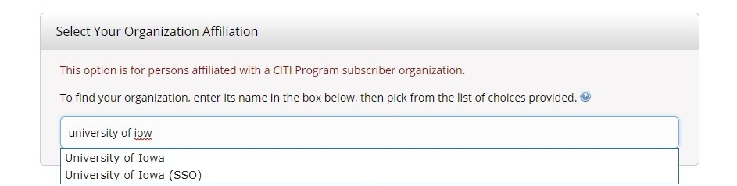

- University of Iowa – Anyone can select this option. You must choose this option if you do not have a UI-issued HawkID.

- University of Iowa SSO – Select this option if you have a UI-issued HawkID and wish to use the UI single sign on (SSO) to access the CITI Program.

- Review the Terms of Service and Privacy Policy for accessing CITI Program materials, then indicate whether you agree to them. Affirm that you are an affiliate of the University of Iowa.


- Sign in using the UI single sign on (SSO) OR create a CITI Program username and password.

If you select ‘Create a CITI Program Account’:
- If you have a UI-issued HawkID, we encourage you to use it as your CITI Program username. (Your HawkID can be found in the UI online directory. Your HawkID is NOT your University of Iowa Employee Number or student ID Number.) Since the CITI Program is used by numerous organizations worldwide, your HawkID may not be available. If this is the case, then create your own username.
- If you do not have a UI-issued HawkID, create your own username.
- Choose a password that is easy to remember. If you are using your HawkID as your username, do NOT use your HawkID password as your CITI Program password.

If you select ‘Log In with University of Iowa’:
- You MUST have a UI-issued HawkID to use the UI single sign on (SSO) login option.
- You will need to use the SSO login option to access the CITI Program for all future log ins. (Keep this in mind if you will only be at the UI for short time. You may want to create your own username and password if your future plans include leaving the UI and going to a different research institution.)

- Select if you would like to connect your ORCID iD to your CITI Program Account. ORCID iD, stands for Open Researcher and Contributor ID. It is a global, not-for-profit that works to support the clear record of research and communication by enabling reliable attribution of authors and contributors.
- Select your country of Residence.
- Select whether CITI can provide information about other courses and services after you complete the courses.
- Select ‘No’ for Continuing Education (CEUs) if you are completing the course as a UI IRB training requirement. For more information about receiving CEUs for CITI Program course completion, see the CITI Program Support Center.
- For your UI profile, complete all fields marked with an asterisk (*).

If you are UI faculty, staff, trainee, or student:
- Enter your HawkID in the last field to assist HSO staff with verifying that you took the correct human subjects protection course.

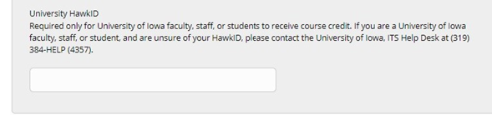

If you are NOT UI faculty, staff, trainee, or student:
    - Institutional email address - Provide the primary email address for questions about your CITI Program records and/or your involvement with a UI research study. If you work for an entity that is collaborating with a UI research team, provide your email address for that entity rather than a personal email.
    - Department - Enter the name of the entity or institution that you work for that will be collaborating with the UI research team. Or enter ‘individual’ if not affiliated with an entity or institution involved in the research.
    - What is your role in research? - Select the best option that most accurately describes your role in the UI research project. The most likely options will be Interviewer, Lab Research Staff, Recruiter, Study Nurse, Study Coordinator, Site Coordinator or Research Assistant.
    - Office Phone - Provide the phone number for questions about your CITI Program records and/or your involvement with a UI research study.
    - University HawkID - Enter the last name of the UI Principal Investigator and the HawkIRB ID number for the UI research study that you will be working on. This information can be provided to you by the UI research team.

NOTE: Before adding you to the Certified Investigator Database, Human Subjects Office staff may contact you to confirm your involvement in research at the University of Iowa or VA Health Care System. Please respond in a timely manner to emails from hso-certifications@uiowa.edu or irb-outreach@uiowa.edu.

- Question 1 - Select the first option, ‘I am required to complete human subjects’ research training.’ to satisfy the UI IRB human subjects protection training requirement.

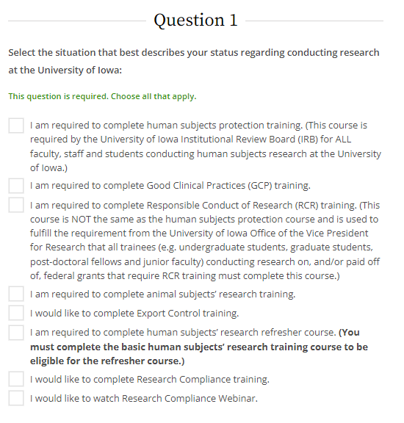

- Question 2 - Researchers in departments that submit to IRB-01 select ‘Group 1 – Biomedical – IRB-01’.
Researchers in departments that submit to IRB-02, you will select ‘Group 2 –Social & Behavioral – IRB-02’.
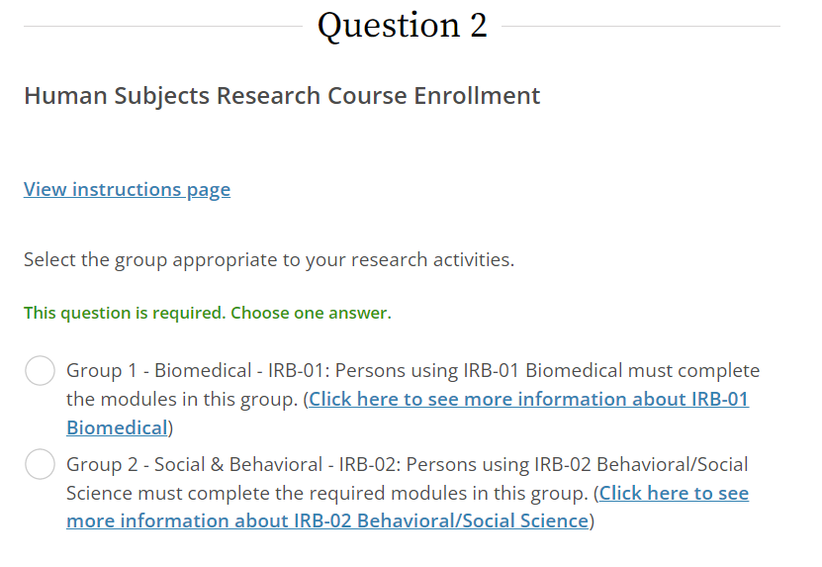

- Click the hyperlinks after each option on the CITI Program page for information about which IRB reviews research for your department or college. This information is also available on the UI IRB page of the Human Subjects Office website.
- If you have questions about which basic course to complete, contact an HSO CITI Program administrator at 319-335-6564.

- Click “Next”

- On the welcome screen, click ‘My Courses’ (if not automatically re-directed)

- Under ‘Courses Ready to Begin’, find the Group 1 or Group 2 course and click ‘Start Now’

- Complete the Assurance Statement and then begin the course.

- Upon completion of the course, print or save a copy of the Certificate of Completion or Completion Report for your records. The Human Subjects Office does not keep copies of any learner’s completion records. Being entered into the Certified Investigator Database is proof of your completion of human subjects protection training for UI research offices and committees.

- The CITI Program will automatically notify the Human Subjects Office that you have completed the course. Allow 2-3 business days for this information to be entered into the Certified Investigator Database. Once that occurs, you may either submit a HawkIRB New Project form as the Principal Investigator (PI) or another PI can add you to a HawkIRB application as a research team member.

Completed training at another institution – Affiliate with UI
The UI IRB does not accept human subjects protection training from other institutions, even if that training was completed through the CITI Program. Each institution establishes the group of modules that meet their requirements for human subjects protection training. Your previous institution may have selected different modules than the UI to meet their requirements. If you completed human subjects protection training at another institution, log in with your previous username and password and choose to affiliate with the University of Iowa. You will be asked to complete any UI IRB-required modules that were not required by your previous institution. You will not have to repeat any UI-required modules that you already completed.
- Log into the CITI Program with the username and password you used to log in when affiliated with your previous institution. If you do not remember your username and/or password, click "Forgot?" and enter your previous e-mail address and username to reset your password.
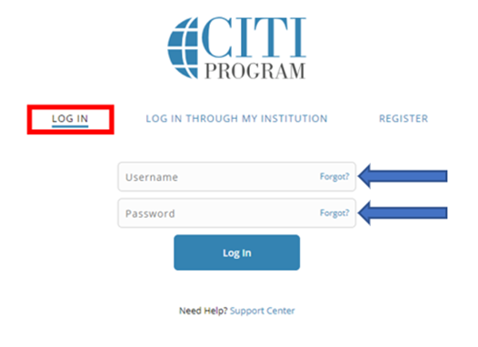

- If you no longer have access to that email account, follow the link at the bottom of the web page to contact the CITI Program Support Center for assistance.

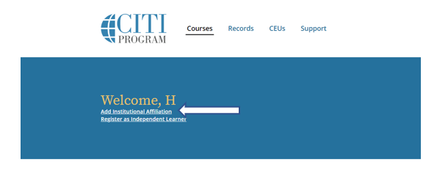
- On the welcome screen, click ‘Add Institutional Affiliation’ or ‘Add an Affiliation’ or the ‘Add Affiliation’ button.

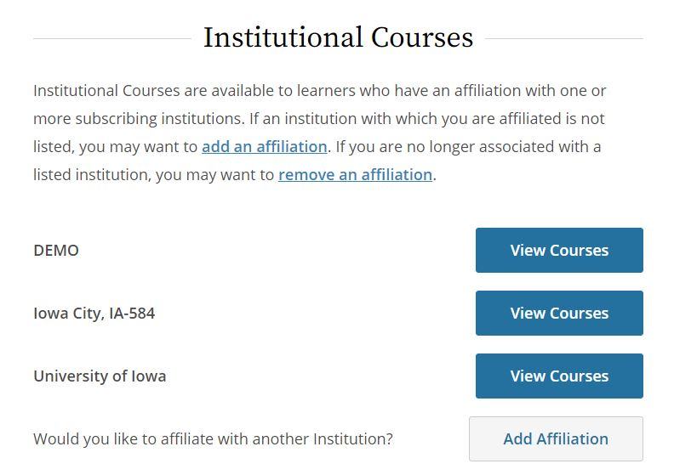

- Select ‘No’ for Continuing Education credit (CEUs) if you are completing the course as a UI IRB training requirement. For more information about receiving CEUs for CITI Program course completion, see the CITI Program Support Center.

- Select whether the CITI Program can contact you in the future to participate in research surveys.

- For your UI profile, you may be asked to enter new demographic information and answer questions for this new affiliation.

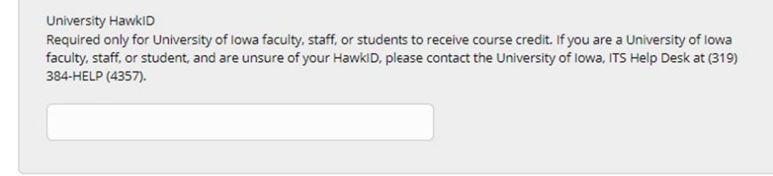
- Complete all fields marked with an asterisk (*). If you are a UI faculty, staff, trainee, or student, please enter your HawkID in the last field to assist HSO staff with verifying that you took the correct human subjects protection course.

- Question 1 - Select the first option, ‘I am required to complete human subjects’ research training.’ to satisfy the UI IRB human subjects protection training requirement.

- Question 2 - Researchers in departments that submit to IRB-01, select ‘Group 1 – Biomedical – IRB-01’. Researchers in departments that submit to IRB-02, select ‘Group 2 –Social & Behavioral – IRB-02’.

- Click the hyperlinks after each option on the CITI Program page for information about which IRB reviews research for your department or college. This information is also available on the UI IRB page of the Human Subjects Office website.
- If you have questions about which basic course to complete, contact an HSO CITI Program administrator at 319-335-6564.

- Click “Finalize Registration”

- On the welcome screen, click ‘My Courses’

- Under the ‘Institutional Courses’ tab, click on ‘View Courses’ for the ‘University of Iowa’

- Under either ‘Active Courses’ or ‘Courses Ready to Begin’, find your desired course and click ‘Continue Course’ or ‘Start Now’

- Complete the Assurance Statement and begin the course. Complete all modules for the course that are not yet completed.

- Upon completion of the course, print or save a copy of the Certificate of Completion or Completion Report for your records. The Human Subjects Office does not keep copies of any learner’s completion record. Being entered into the Certified Investigator Database is proof of your completion of human subjects protection training for UI research offices and committees.

- The CITI Program will notify the Human Subjects Office that you have completed the course. Please allow 2-3 business days for this information to be entered into the Certified Investigator Database. Once that occurs, you may either submit a HawkIRB New Project form as the PI or you can be added to a HawkIRB application as a research team member for another PI.

Additional Courses
For UI researchers, human subjects protection training is a one-time requirement. However, some study sponsors require researchers to renew this training every few years after completing the basic course. Additionally, researchers who are involved in the conduct, oversight or management of NIH-funded clinical trials are required to complete training in Good Clinical Practice (GCP) and renew this training every 3 years. As a courtesy to UI researchers and to ensure compliance with sponsor requirements, the UI offers biomedical and social/behavioral human subjects protection refresher courses and GCP basic and refresher courses on the CITI Program.
Follow these instructions to register for additional courses under your CITI Program user profile. (If you do not have a CITI Program user profile, complete steps 1-8 in the ‘Creating a New Profile for First Time Completion of Human Subjects Protection Training’ section of this Guide first, then begin with step 5 below):
- Log into the CITI Program using either your username and password or using the UI single sign on (SSO) with your HawkID and password.
- On the welcome page, click ‘My Courses’.
- Under the ‘Institutional Courses’ tab, click ‘View Courses’ for the ‘University of Iowa’.
- Scroll to the bottom and click ‘Add a Course’ under the ‘Learner Tools for University of Iowa’.
- Select the appropriate course to register. The curriculum selection page will display other courses for the University of Iowa. Completion of courses for the Responsible Conduct of Research, animal subjects research and Export Control are not required by the UI IRB.
- Select ‘I am required to complete human subjects’ research refresher course.’ if you need to renew your UI human subjects protection training at the request of a funding agency, sponsor, or coordinating center. This is not an IRB requirement and does not satisfy the UI human subjects protections training requirement for UI researchers. Do not complete a refresher course if you completed:
  - The NIH tutorial "Protecting Human Research Participants" to satisfy the UI IRB requirements for human subjects protection training,
  - An HSO Workshop to satisfy the UI IRB requirements for human subjects protection training, or
  - Human subjects protection training in the CITI Program at a previous institution.

If any of these situations apply to you, you must first complete the UI basic course for either ‘Group 1 – Biomedical - IRB-01’ or ‘Group 2 – Social/Behavioral – IRB-02’. Subsequent renewals can then be satisfied by completing the refresher course. If you selected the wrong training, click ‘Start Over’.
- Select ‘I am required to complete Good Clinical Practices (GCP) training.’ if you need to complete GCP training. See below for instructions.
- Select ‘I am required to complete Responsible Conduct of Research (RCR) training.’ if your department requires you to complete this training.
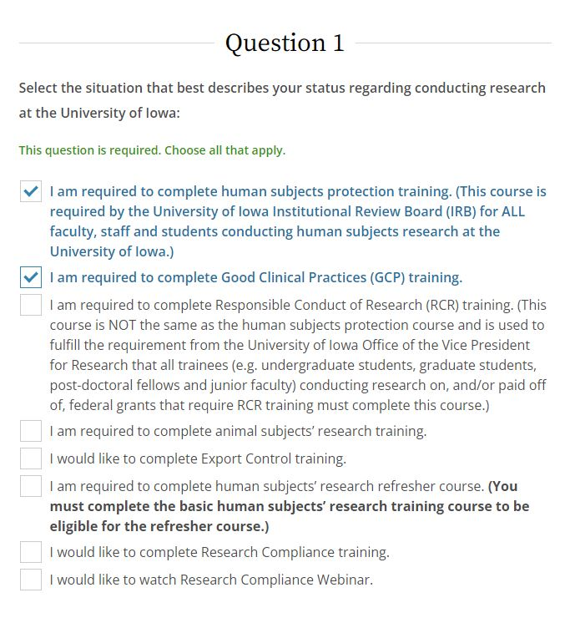
- Click ‘Next’ and respond to additional questions about the training course/s you selected:

For GCP Training:
- Question 1 - Select the second box, ‘I am required to complete Good Clinical Practice (GCP) Training’.

- Question 2 - Select Group 1-Biomedical (IRB-01) or Group 2-Social & Behavioral (IRB-02) based on the board to which you will submit.

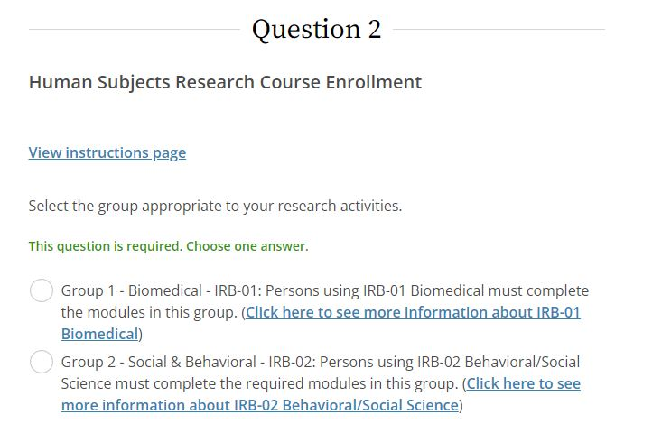

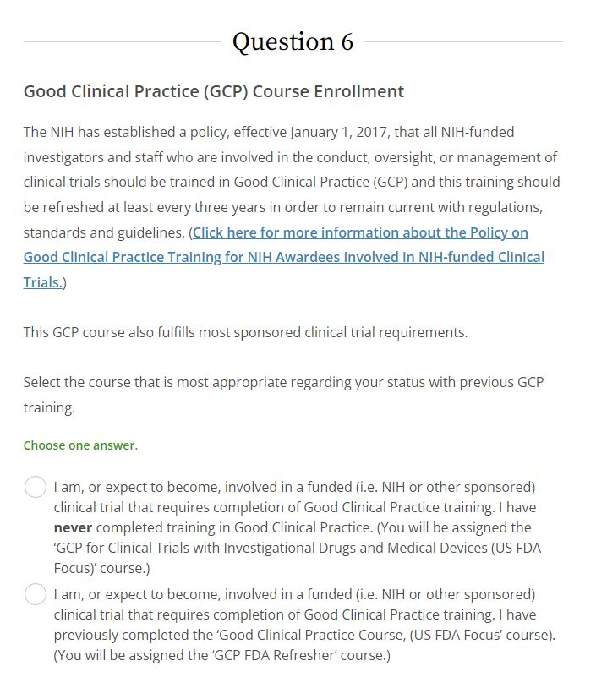
- Question 6 -
- Select the first option if you never completed this training before. You will be automatically to the course, ‘GCP for Clinical Trials with Investigational Drugs and Medical Devices (US FDA Focus)’ by the CITI Program.
- Select the second option of you previously completed GCP training and are required to renew this training. You will be assigned the course, ‘GCP FDA Refresher’ by the CITI Program.

- You have the option of completing additional GCP courses if your study sponsor requires GCP training with ICH focus, or if you would like additional GCP training involving clinical investigations of devices. Select all options that apply to you and click ‘Next’. However, if these options do not apply to you, simply click on ‘Next’ without selecting any of the optional courses.

- Click ‘Next’ at the bottom of each screen until you are directed back to the ‘Courses’ screen. If you selected the wrong training, click ‘Start Over’.

On the ‘Courses’ screen, scroll down to ‘Courses Ready to Begin’ and click the title of the course you want to complete.

- Complete the Assurance Statement to begin the course.

- Upon completion, print or save a copy of the Certificate of Completion or Completion Report for your records. The Human Subjects Office does not keep copies of any learner’s completion record.
- For human subjects protection refresher training: The Human Subjects Office is not notified of your completion of the human subjects protection refresher course. This information will not be recorded in the Certified Investigators Database.
- For GCP Training: The Human Subjects Office will be notified of your completion of any of the GCP training courses. This information will be entered into the Certified Investigator Database as a courtesy to UI researchers.

Department of The Navy training
Follow these instructions to register for additional courses under your CITI Program user profile. (If you do not have a CITI Program user profile, complete steps 1-7 in the ‘Creating a New Profile for First Time Completion of Human Subjects Protection Training’ section of this Guide first, then begin with step 5 below):
- Log into the CITI Program using either your username and password or using the UI single sign on (SSO) with your HawkID and password.

- On the welcome screen, click the ‘Add Institutional Affiliation’ or ‘add an affiliation’ links or ‘Add Affiliation’ button.

- To find the organization, type in ‘Department of the Navy’.

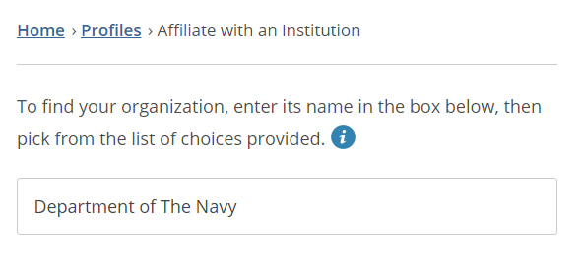

- For your Department of the Navy profile, all fields marked with an asterisk (*) MUST be completed.

- Question 1 - Select the option, “I am conducting, planning to conduct or am otherwise involved in research with human subjects, tissues from humans and/or patient records.”

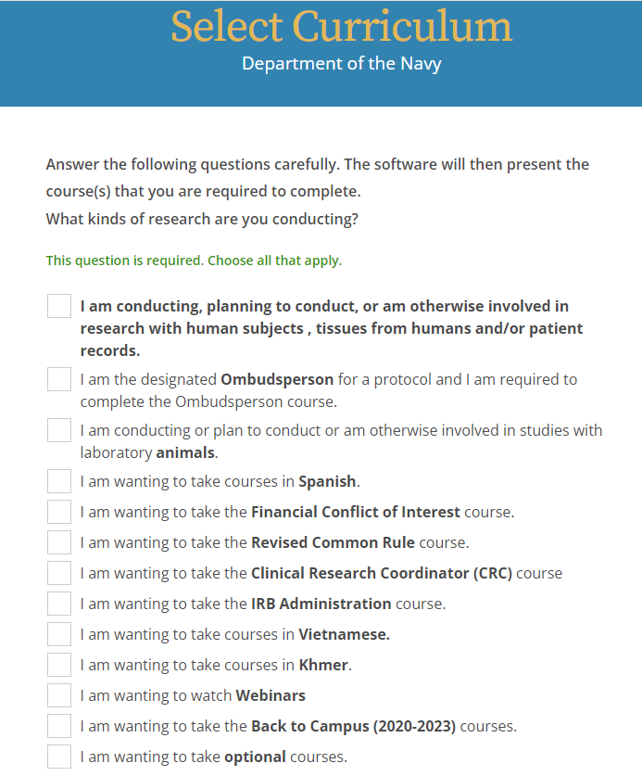

- Question 2 - Select the option that best describes your research focus.
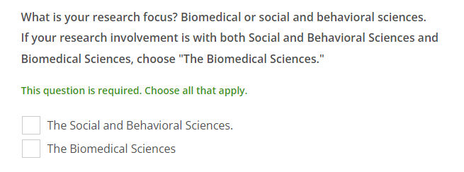

- Select the appropriate research role.

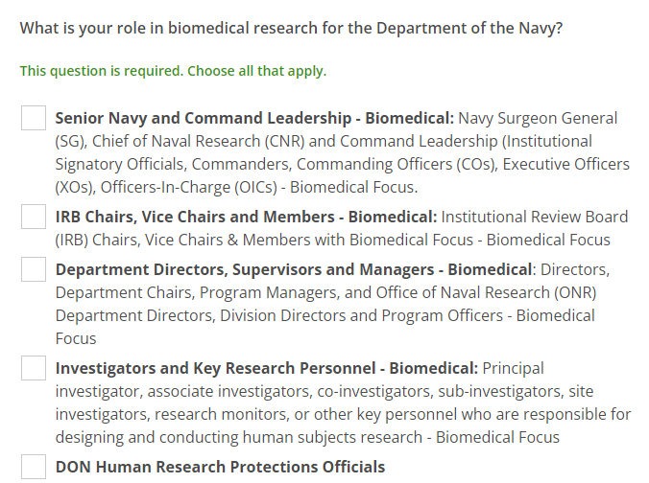

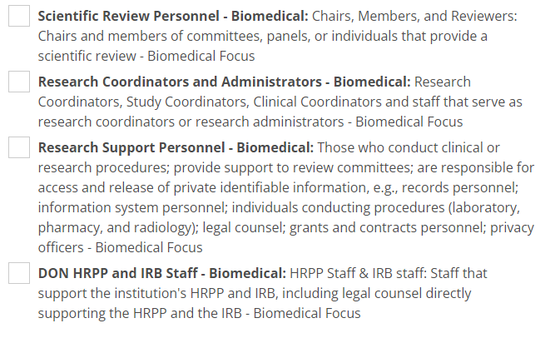

- On the welcome screen, select the Institution, Department of the Navy.

- Click on ‘View Courses’ next to Department of the Navy.

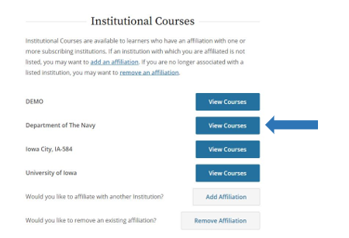

- Under ‘Courses Ready to Begin’, find your desired course and click ‘Continue Course’ or ‘Start Now’ to enter it.

- Once you complete the Assurance Statement, the CITI Program will allow you to start the course.

- After completing all modules for the course, print or save a copy of the Certificate of Completion or Completion Report for your records. The Human Subjects Office does not keep copies of any learner’s completion record.

Optional Compliance Courses and Webinars
Follow these instructions to register for optional compliance courses and webinars that are available to all learners affiliated with the UI:
- Log into the CITI Program using either your username and password or using the UI single sign on (SSO) with your HawkID and password.
- On the “My Courses” page, click “View Courses” next to “University of Iowa.”
- Either click “Learner Tools” or scroll all the way to the bottom of the page to see the “Learner Tools for University of Iowa” box.
- Click “Add a Course.”

- At the bottom of the list on the “Select Curriculum” page are two options—one for Research Compliance training and one for Research Compliance webinar:



- The Research Compliance training option will open a list of optional training courses on topics such as conflict of interest, information privacy and undue foreign influence.
- The Research Compliance Webinar option will open a list of a number of CITI Program webinars on topics such as clinical research and Good Clinical Practice, grants and blockchain/higher education.
- Click “Next”

- Select the courses and/or webinars that you would like to review, then click “Next”

- You will be directed back to the “My Courses” page. You will find these courses under “Courses Ready to Begin”, in alphabetical order.

Instructions for Learners Affiliated with the VA Health Care System (VAHCS)
This section contains instructions about how to register for the first time as a CITI Program user/VAHCS learner, what to do if you need to obtain a UI-issued HawkID and how to add a refresher course as a VAHCS learner once you are registered with the CITI Program.

Create a Profile (first time users) - VAHCS Researchers

NOTE: Carefully follow these steps to complete the correct training.

- Go to CITI Program home page.
- Click ‘Register’
- In the ‘Select Your Organization Affiliation’ section, type ‘VA Iowa City, IA-584'
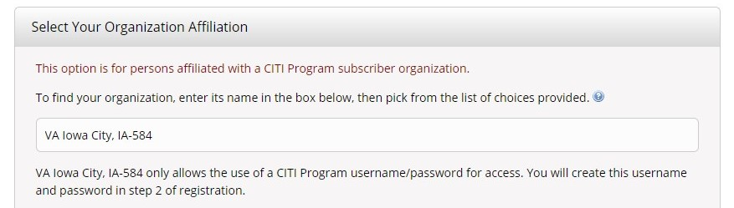

- Review the Terms of Service and Privacy Policy for accessing CITI Program materials, then indicate whether you agree to them. Affirm that you are an affiliate of the Iowa City VAHCS.

- You may then create a CITI Program username and password.

When you create a CITI Program Username/Password:
- If you have a UI-issued HawkID, we encourage you to use it as your username. Since the CITI Program is used by numerous organizations worldwide, your HawkID may not be available. If this is the case, then create your own username.
- If you do not have a UI-issued HawkID yet, create your own username.
- Choose a password that is easy to remember. If you are using your HawkID as your username, do NOT use your HawkID password as your CITI Program password.

- Select ‘No’ for receiving Continuing Education credits (CEUs) if you are completing the course as an IRB training requirement. For more information about receiving CEUs for CITI Program course completion, see the CITI Program Support Center.

- Select whether the CITI Program can contact you in the future to participate in research surveys.

- For your VAHCS profile, complete all fields marked with an asterisk (*). If you are a UI faculty, staff, trainee, or student, or have a UI-issued HawkID, enter your HawkID in the last field to assist HSO staff with verifying that you took the correct human subjects protection course.
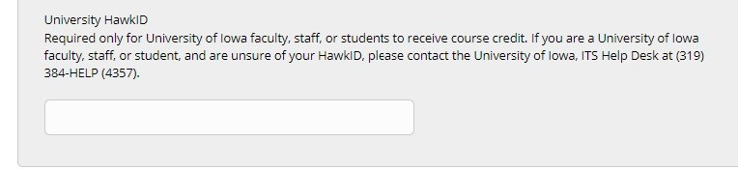
- Question 1 - On the Select Curriculum page, select the second option that states ‘I am (or expect to become) involved in research with human subjects at the VA, but have never completed training in human subjects protection that satisfies VA requirements, or have been told that I must take the Basic course.’ You will be automatically registered for the basic VA Human Subjects Protection course.

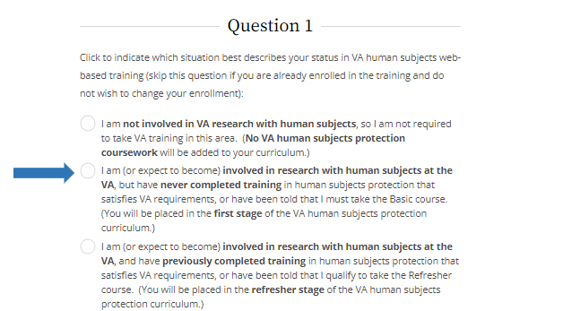

- Answer the remaining questions on the page about additional training that you would like to complete. Then click on the ‘Submit’ button at the bottom of the screen.

- Click ‘Finalize Registration’

- On the welcome screen, click ‘Courses’

- Under either ‘Active Courses’ or ‘Courses Ready to Begin’, find your desired course and click ‘Continue Course’ or ‘Start Now’.

- Complete the Assurance Statement to begin the course.

- Upon completion, print or save a copy of the Certificate of Completion or Completion Report for your records. The Human Subjects Office does not keep copies of any learner’s completion record. Being entered into the Certified Investigator Database is proof of your completion of human subjects protection training for UI and VAHCS research offices and committees.

- The CITI Program will automatically notify the Human Subjects Office that you have completed the course. Please allow 2-3 business days for this information to be entered into the Certified Investigator Database. Once that occurs, you may either submit a HawkIRB New Project form as the Principal Investigator (PI) or another PI can add you to a HawkIRB application as a research team member.

Obtain a HawkID - VAHCS Researchers
You must have a UI-issued HawkID before your completion of the VAHCS human subjects protection training can be entered into the Certified Investigator Database. A HawkID is a personal username that is assigned by the UI to anyone who needs to access the eResearch (HawkIRB) system.
- If you have a dual appointment with the UI and VAHCS, use your assigned HawkID.
- To request a HawkID, send an email to irb@uiowa.edu and provide with the following information:
  - Your name
  - Name of your VAHCS department or clinic
- You will be asked to provide the following information directly to University of Iowa Information Technology Services (ITS)
  - Social security number
  - Date of birth

Human Subjects Protection Training Refresher Course - VAHCS Researchers
VAHCS researchers are required to renew their training every three years. VAHCS credentialing requirements are maintained and monitored by the VA Research Office. Failure to adhere to these re-certification requirements could result in the VA Research Office issuing restrictions to conduct VA related research activities.
You will receive automated emails from the CITI Program to alert you that your VAHCS human subjects protection training is due for renewal.
To complete a refresher course, follow the instructions below:
- Log into the CITI Program using your username and password.

- On the welcome page, click on the ‘Courses’ link.

- Under ‘Institutional Courses’, click on ‘View Courses’ for ‘Iowa City IA-584’.

- Scroll to the bottom and click on the ‘Add a Course’ link in the ‘Learner Tools for ‘Iowa City IA-584’’ box.

- Select the last option that states ‘I am (or expect to become) involved in research with human subjects at the VA, and have previously completed training in human subjects protection that satisfies VA requirements, or have been told that I qualify to take the Refresher course. You will be placed in the refresher stage of the VA human subjects protection curriculum.

- Answer the remaining questions on the page about additional training that you would like to complete. Then click on the ‘Submit’ button at the bottom of the screen.

- Complete the Assurance Statement to being the refresher course.

- Upon completion, print or save a copy of the Certificate of Completion or Completion Report for your records. The Human Subjects Office does not keep copies of any learner’s completion record. Being entered into the Certified Investigator Database is proof of your completion of human subjects protection training for UI and VAHCS research offices and committees.

The CITI Program will automatically notify the Human Subjects Office that you have completed the course. Please allow 2 to 3 business days for this information to be entered into the Certified Investigator Database.

Documentation of Human Subjects Protection Training

CITI Program Training
Researchers should maintain a record for any courses completed through the CITI Program in their own records. Upon completion of a training course, there will be an option to print or save a copy of the Completion Certification or Completion Report. You do not need to provide this report to the Human Subjects Office, but you might need to provide this report to a sponsor or funding agency.
The Human Subjects Office receives an automated notice from the CITI Program when the following courses are completed by either UI- or a VAHCS-affiliated learner:
- Basic course for Group 1 - Biomedical - IRB-01.
- Basic course for Group 2 - Social-Behavioral - IRB-02.
- Basic course for VA Human Subjects Protection.
- Refresher course for VA Human Subjects Protection.
- Basic Good Clinical Practice Course.
- Refresher Good Clinical Practice Course.
- GCP Course for Clinical Trials Involving Investigational Drugs.
- GCP Course for Clinical Trials Involving Investigational Medical Devices.
Within 2-3 business days of receiving this notice, HSO staff enters the learner’s completion record into the Certified Investigator Database. This database is linked to the HawkIRB system so it will recognize when a UI or VAHCS learner/research team member has completed the training requirements. This will be reflected in Section II of the HawkIRB application. However, HawkIRB does not recognize when a non-UI team member has completed the training requirements.
The Human Subjects Office does not keep documentation of human subjects protection training for any affiliated learners.
To obtain a copy of your Completion Certification or Completion Report, log into the CITI Program using either your username and password or using the UI single sign on (SSO) with your HawkID. There are 2 ways to find your completion documentation:

Option 1
  - On the welcome page, click ‘Courses’
  - Under the ‘Institutional Courses’ tab, click ‘View Courses’ for either ‘University of Iowa’ or ‘Iowa City IA-584’
  - Scroll down to the ‘Completed Courses’ section to find the course that you need completion documentation for and click on ‘View – Print – Share Record’
Option 2
  - On the welcome page, click ‘My Records’

  - Change the filter to see all courses for a specific active institutional affiliation or click ‘Show All’ to see course completion data for both your current active affiliations and past affiliations that are no longer active

  - Find the corresponding course under either ‘University of Iowa Records’ or ‘Iowa City, IA-584 Records’ and click ‘View-Print-Share’ in the ‘Completion Record’ column.
You will have access to either a Completion Report (which shows all the modules that were completed, what date they were completed and your scores for each) or a Completion Certificate (which shows that the course and date completed). You will have the option to view and print the Report/Certificate or copy a link to the Report/Certificate.

NIH Tutorial Certificate of Completion
Prior to March 2008, researchers were allowed to use the National Institutes of Health (NIH) tutorials as human subjects protection training. The certificates of completion for these tutorials are no longer available from the NIH. The HSO does not keep documentation of human subjects protection training for any affiliated learners. Investigators who did not keep a copy of their NIH/NCI completion certificates will have to complete an NIH-accepted course for human subjects protection training if they must provide proof of completion of this training for a sponsor or funding agency. The CITI Program courses are accepted by NIH.
NOTE: In September 2018, NIH discontinued the course on Protecting Human Research Participants.

